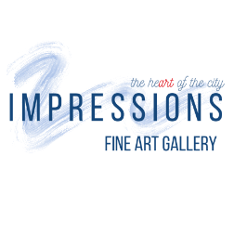
IMPRESSIONS GALLERY
ARTIST APPLICATION

Name: Date:

Address:

City: State/Zip code:

Cell Phone: Other Phone:

Email:

Website (if applicable):

Artist medium:

How many pieces do you have ready to exhibit/sell that you can present to us?

Price range of pieces to sell:

Would you be willing to conduct classes/workshops in your area of expertise? □Yes □No
If yes, please list your class preference and age range of attendees:

What locations (galleries, storefronts, restaurants, etc) do you currently show your work? Please list all locations by name and number of art pieces presented in each location.

Please attach your Artist Biography and digital photos (maximum of 8) of your artwork. Please note that the jury will determine the art selected from samples. Review the Art Exhibit Procedures document for more information.
For Impressions Gallery Team use

________________________________________ _____________________ □Yes □No
Received by Date Received $25 Application Fee Paid
□Cash □CC □Check

□Accepted □Not Accepted at this time

Notes:

